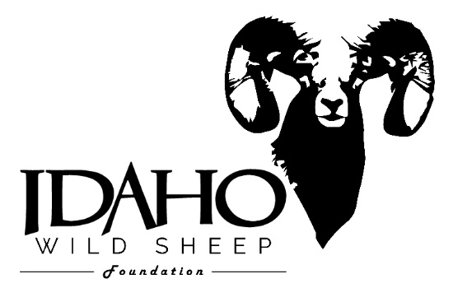Story Submission Guidelines
Idaho Wild Sheep Foundation Journal
The Idaho Wild Sheep Foundation is actively seeking entertaining hunting stories for our bi-annual journal. With this publication we seek to inform, educate, and entertain our readers. Our journal serves as a platform for our valued members to share your exciting hunting stories with all our readers. Stories can be longer feature stories, short hunting reports or high-quality member trophy photos. Any hunting or fishing story will be considered.
Guidelines
- Submittals must be from a current Idaho WSF member. Membership can be purchased at any time on our website.
- Ideally, feature stories should be between 1,000 to 3,000 words in length submitted in Word.
- Include high quality photos. If photos are taken by a phone, camera settings should set to high quality. Cover story submittals require a high quality, portrait orientation photo. We highly encourage additional photos of scenery and hunter experiences. The trophy must be presented in a respectful manner.
- Information to be included with story:
Name
Date (year) of hunt
Location
Guide/outfitter (if applicable)
Please note if the hunt was acquired by an Idaho WSF event or raffle

Cover story will be selected by the journal committee. Cover story will be selected based on content, photos and being publish ready. The editor and/or committee may edit articles for content and length. The Idaho Wild Sheep Foundation reserves the right to reject any materials found to be objectionable, or which promote unethical or illegal hunting practices. Furthermore, the Idaho WSF reserves the right to publish materials at its discretion and timeline.

Deadlines for submission:
Summer issue: May 1
Winter issue: November 1

Submit articles by email to info@idahowildsheep.org or, by flash drive (no CD’s) mailed to Idaho WSF, P.O. Box 8224, Boise, Idaho 83707.

All submittals will receive an Idaho WSF hat and the story chosen for the cover will receive a Kryptek vest with Idaho WSF logo. These items will be shipped after the publication is complete.

We look forward to hearing about your successful hunts!

Idaho Wild Sheep Foundation
www.idahowildsheep.org
208-345-6171

