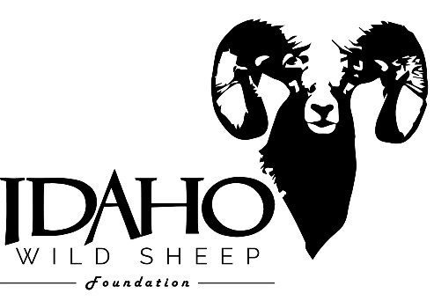
ENTRY FORM
Id WSF Warriors Tribute CONTEST

The Idaho Wild Sheep Foundation is proud to offer a disabled Veteran Warrior the opportunity to purchase an All-Terrain track chair or, prosthetics of up to $15,000.00 in value. This contest is made by possible by an Idaho WSF member. It gives a disabled Veteran Warrior the opportunity to hunt and enjoy the outdoors.
Rules:
- Nomination must come from a current Idaho WSF member.
- Nomination is for a disabled Veteran Warrior of the Armed Forces or National Guard disabled during service.
- Only Veterans with an Honorable, Medical or General Discharge status are eligible.
- Entry form must be completed and submitted by April 5, 2021. Incomplete entry forms will not be considered.
- Idaho WSF members may self-nominate.
- Include a copy of your military ID.

Idaho WSF member information:
Name:
Address:
Phone:
Email:

Name of Veteran Warrior being nominated:
Name:

________________________________________________
Signature Idaho WSF member Date

To be completed by nominee:

Name:
Address:
Phone:
Email:
Relationship to member:
Branch of service:
Dates of service:
Date of disablement:
Circle one:
Honorable discharge Medical discharge General discharge
Type of device needed:
Approximate cost of device:
Required: Essay to be completed by nominee. On additional sheet(s) of paper list why you are deserving of this award, your story and/or, how it would impact your life. Limit of 600 words or less.
I certify that all the information provided is accurate.

Nominee signature Date
Submit both forms, copy of military ID and, essay by mail or email to:
Idaho Wild Sheep Foundation
P.O. Box 8224
Boise, ID 83707
208-345-6171
Email: info@idahowildsheep.org

Award will be presented at the Idaho WSF Banquet and Fundraiser to be held June 12, 2021.

